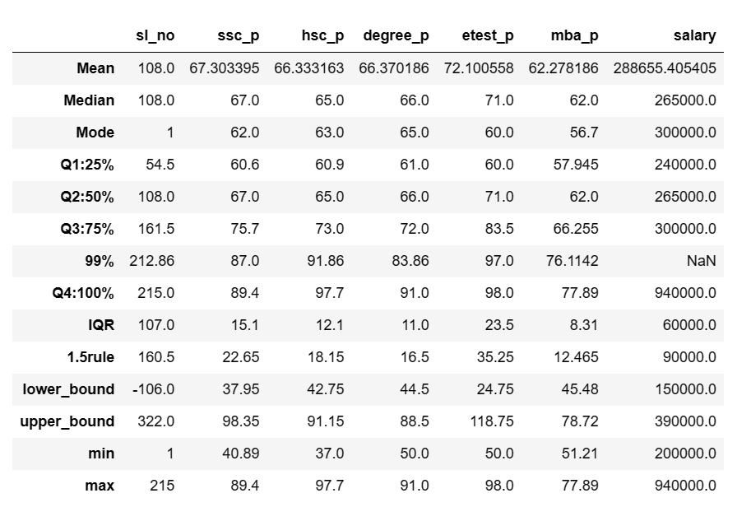

MBA data set

SSLC

min value 41 , max val 89

lower bound : 38 , upper bound 98

min value is not less than lower bound

max value is not higher than upper bound

12th

min value 37 , max val 98

lower bound : 43 , upper bound 91

min value is less than lower bound so need to replace with lower bound value 43

max value is higher than upper bound need to replace with upper bound value

Degree

min value 50 , max val 91

lower bound : 44 , upper bound 88

min value is not less than lower bound

max value is higher than upper bound need to replace with upper bound value

entrance

min value 50 , max val 98

lower bound :24 , upper bound 118

min value is not less than lower bound

max value is not higher than upper bound

MBA

min value 51 , max val 78

lower bound : 45 , upper bound 78

min value is not less than lower bound

max value is not higher than upper bound

salary

min value 200000 , max val 940000

lower bound : 150000 , upper bound 390000

min value is not less than lower bound

max value is higher than upper bound need to replace with upper bound value